* Print this in console:

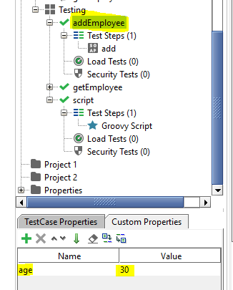

* Ans: Project > test suite > Test cases > Test step

testRunner.testCase.testSuite.testCases["addEmployee"].getPropertyValue("age")

* Reach here

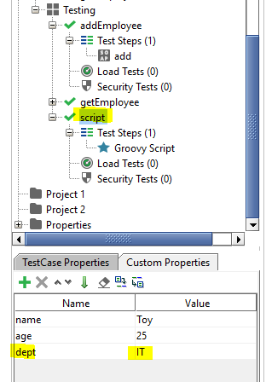

Ans:

log.info testRunner.testCase.getPropertyValue("dept")

* To get Request Property of test step get:

log.info testRunner.testCase.testSuite.testCases["getEmployee"].testSteps["get"].getPropertyValue("Request")

* Below code will setProperty value:

testRunner.testCase.testSuite.testCases["getEmployee"].setPropertyValue("id","24")

